Cairo University CHS – Team 1

Faculty of Engineering

Computer Engineering Department

CMPN202

Introduction to Database Systems

Bikers’ Code

Database Schema Report

Team Number: 1

**Team Members:**

Amr Hesham Afifi 1162377

Kareem Abdelhameed Zaghw 1162318

Mostafa Hazem Abdelghafaaar 1162398

Seifeldin Ahmed Elsehely 1162302

**Contact Info:**

[mostafahazem1998@gmail.com](mailto:mostafahazem1998@gmail.com)

**18/11/2018**

New ER Diagram:

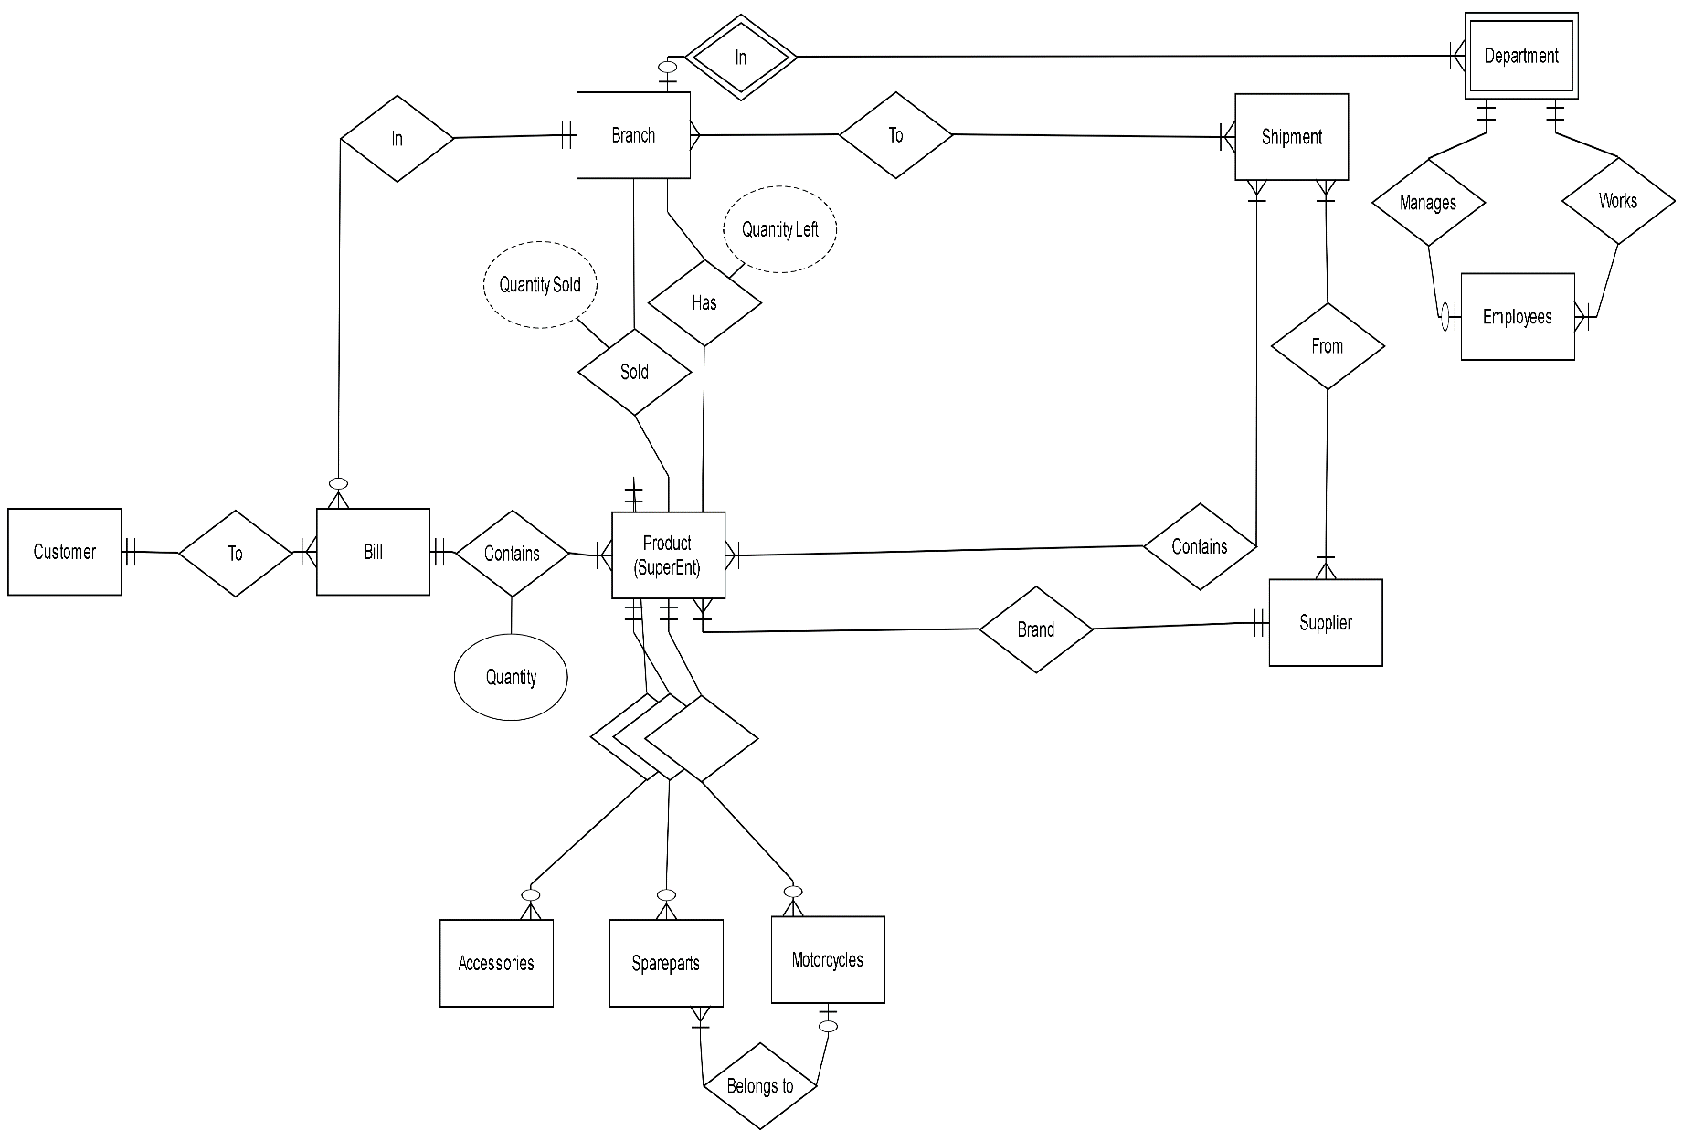

Schema Diagram:

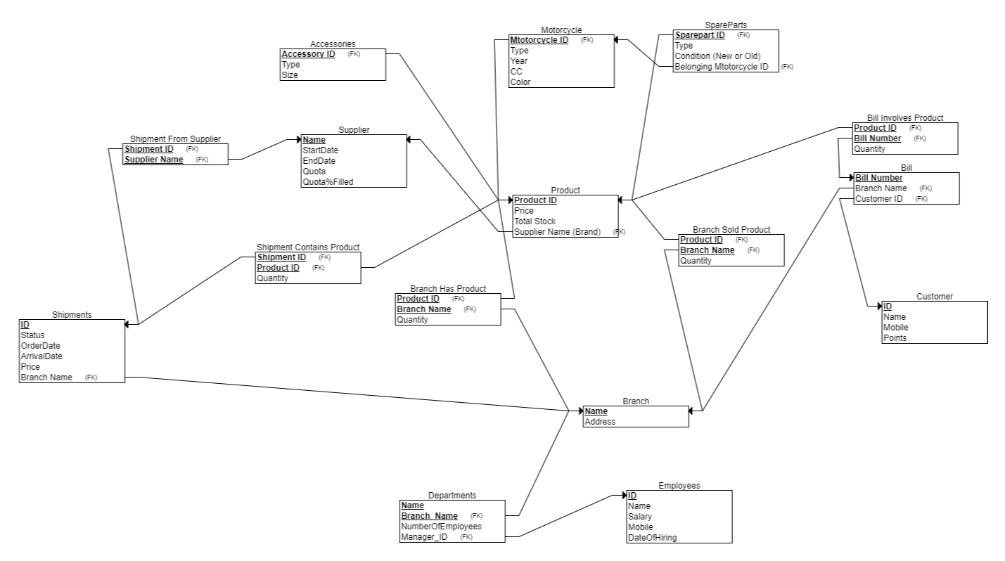

Database Constraints:

* Key constraint:

All primary keys in all tables are unique for each tuple, this was took in consideration by assigning a minimal unique attribute as a primary key to each table.

* Entity integrity constraint:

All primary keys in all tables can’t have null values in any tuple, this will be implemented as a validation on entry in all tables.

* Referential integrity constraint:

A foreign key can take the value of a primary key in another table or take NULL value. Implemented by linking tables using foreign keys, which are primary keys in their main tables, and in case of not being linked to the other table the foreign key takes a NULL value.

* Domain constraint:

Every value in a tuple must be from the domain of its attribute, datatypes that will be given in the implementation will cover this constraint.

* Semantic integrity constraint:

The values in all tuples shouldn’t violate the logical maximum or minimum of its attribute in the database. This will be considered in data-entry by the system users and validation checks can be designed to ensure this constraint won’t be violated by users.